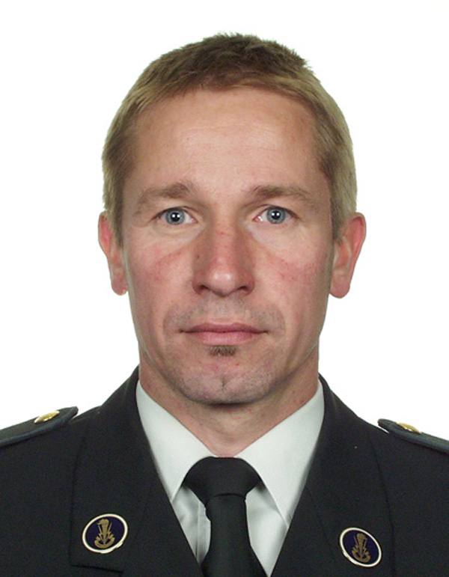
Bart Scheers, Dr. Ir. was born in Rumst, Belgium, in November 1966. He received his degree of engineer, with a specialization in telecommunications, from the Royal Military Academy in 1991. After his studies he served as an officer in a territorial signal unit of the Belgian Army. In 1994 he became assistant at the Royal Military Academy in the field of signal processing. In 2001 he presented his PhD thesis on the use of ground penetrating radars in the field of humanitarian demining. From 2000 he works as an associate professor in the “Communications Information Systems and Sensors” (CISS) department, in the field of telecommunication systems and networks. His current domains of interest are Mobile Ad Hoc Networks (layers 2 and 3) and Cognitive Radio.

